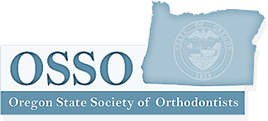

Oregon State Society of Orthodontists Annual Meeting
November 30, 2018

Course Title: Medical Emergencies in the Dental Office
Instructor: Dr. Erik Richmond
Hours: 3.0

Course Title: OHSU Resident Research Presentations
Hours: 1.0

Riddhi Desai, DMD: Differences in Temporomandibular Joint Loading Forces Between Dolichofacial and Brachyfacial Phenotypes: A Longitudinal Cephalometric Study

Ji Sun Min, DMD: Vertical Changes with Clear Aligner Therapy

Amelia Stoker, DMD: Graduate Orthodontic Residents’ Perspectives on Education: A Follow-up Study

Jonathan Yih, DMD: Evaluation of a Novel Microencapsulated Orthodontic Cement to Prevent White Spot Lesions

I hereby proclaim that the above is an accurate representation of the course I attended and the hours of continuing education that I earned.

Name of attendee: ____________________________________________________

Signature of attendee:__________________________________________________

Oregon State Society of Orthodontists
www.ossortho.org
oregonorthodontics@gmail.com

